CMSC 430 Project 3 Documentation

**Approach**:

My initial approach to this project was downloading the Project 3 Skeleton Code and merging parser.y and scanner.l with what I had previously added to the lexical and syntactical analyzers. I then added the necessary enumerations to values.h. Once I was sure that my productions were in the correct bottom-up order in parser.y, I began to add more cases to the evaluation functions in values.cc. I then added a functioning if/else production and worked on accepting parameters from the command line. Finally, I tried to figure out the case statement but ran out of time and mental capacity.

**Test Plan:**

1. **Testing Arithmetic Operators - SUCCESS**

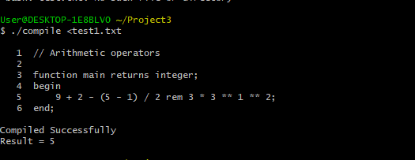

1. **Testing Relational and Logical Operators - SUCCESS**

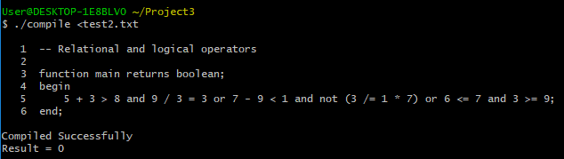

1. **Testing Conditional Expressions - SUCCESS**

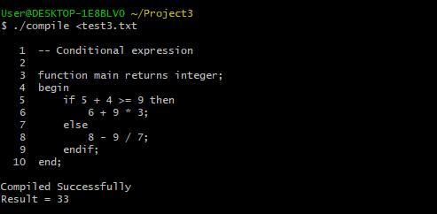

1. **Testing Case Selection - FAIL**

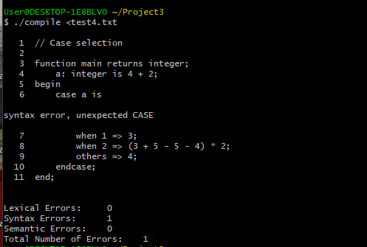

1. **Testing Function with a Reduction - SUCCESS**

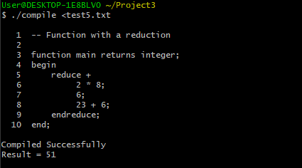

1. **Testing Multiple integer variable initialization - SUCCESS**

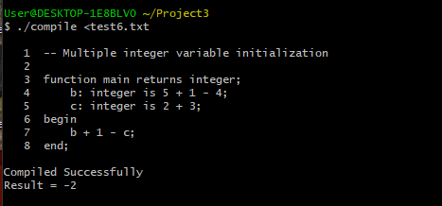

1. **Testing Nested If - SUCCESS**

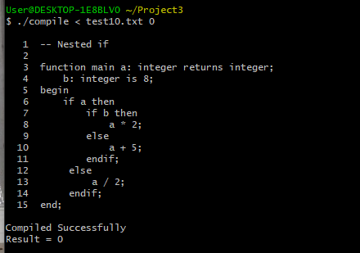

1. **Testing Nested Reduction - SUCCESS**

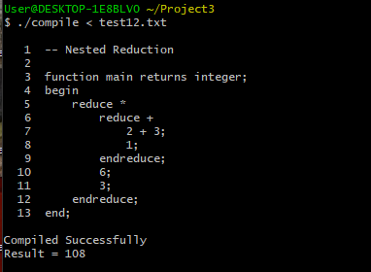

1. **Variable initialization with real and Boolean variables - FAIL**

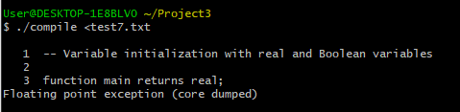

After making changes to the Boolean values in parser.y, I began to get this floating point exception error.

1. **2 Parameter Declarations – SUCCESS**

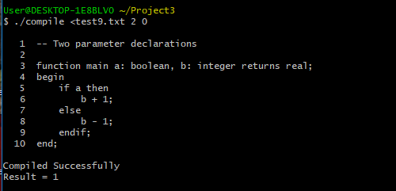

**Lessons Learned:**

I have learned from the past 3 projects that I have a fundamental misunderstanding of compiler theory and design. I am missing something so rudimentary that everyone seems to have grasped. For some reason the readings and the videos do not contain the answers that I need. I hope the future readings make more sense to me.